EXPERIMENT 1
Create a Kanban Board to Visualize the Tasks.
- Create Columns for To Do, In-Progress and Done.
- Add Atleast 5 Sample Tasks
- Move the Tasks across the Columns to Simulate the Workflow.
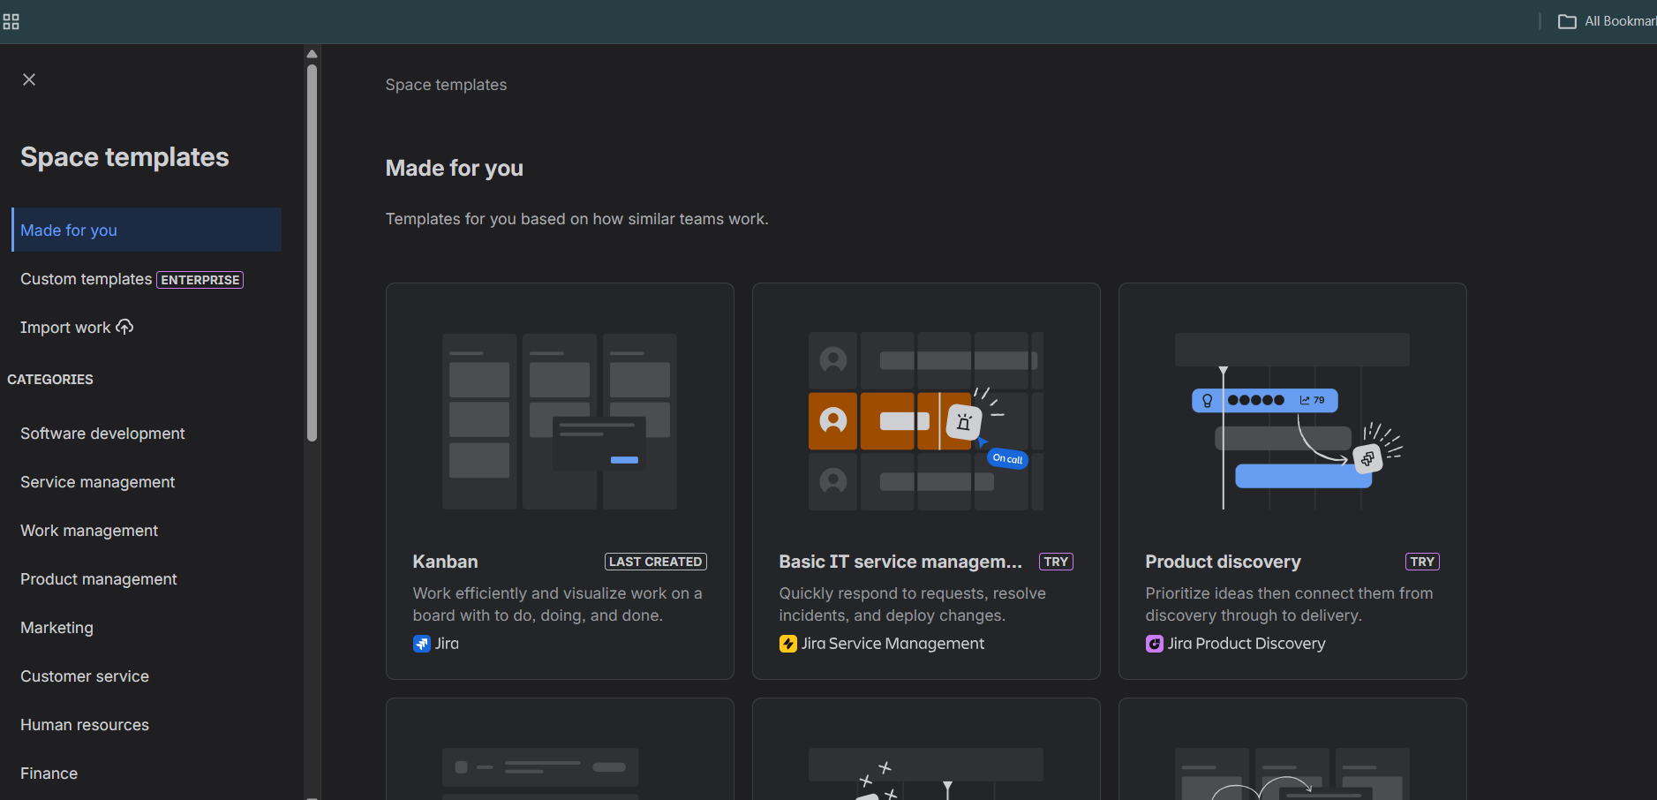

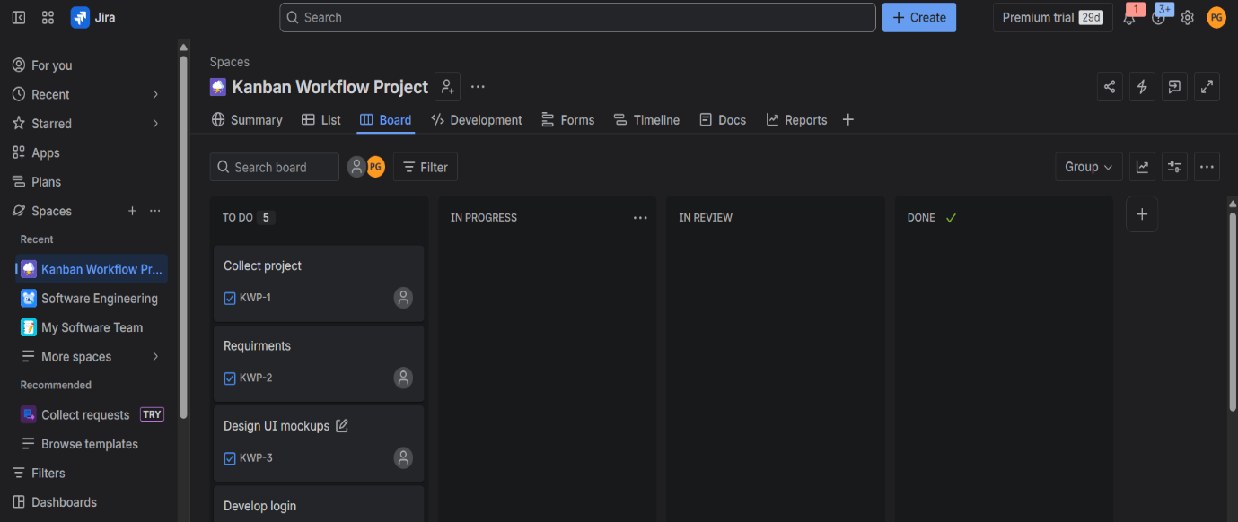

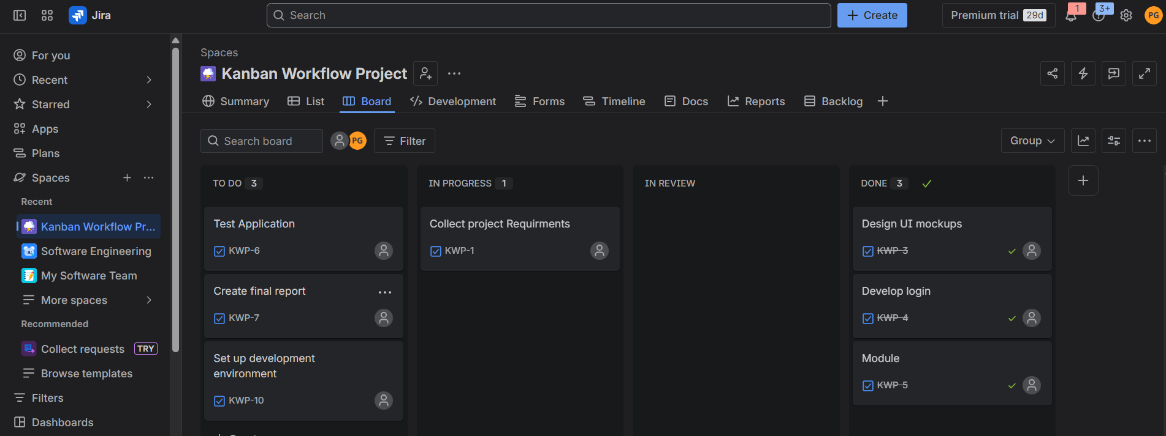

EXPERIMENT 2
Sketch a Simple Prototype of a Bus Ticket Booking System using
Figma Tool

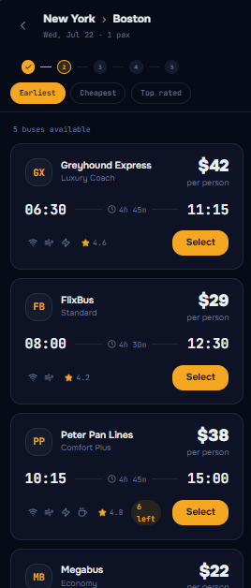
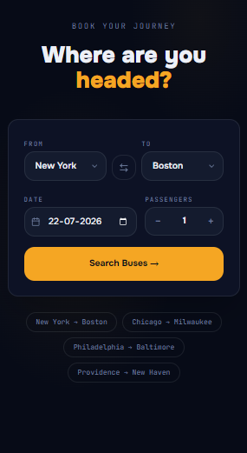

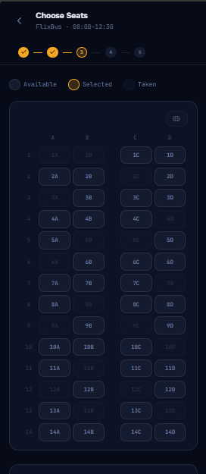
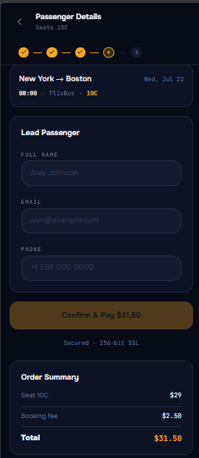

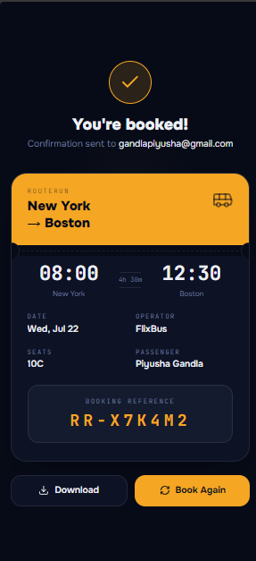

EXPERIMENT 3
Design an E-Commerce Mobile Application Prototype using Figma

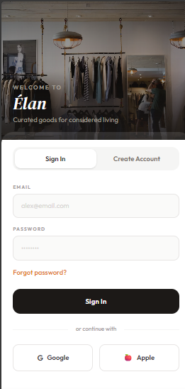
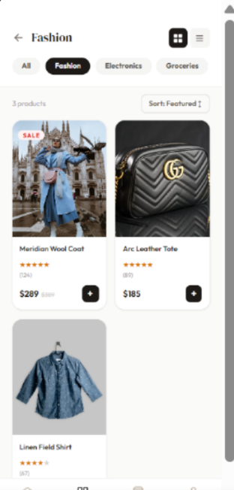
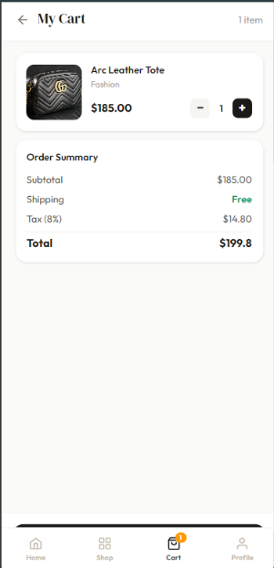

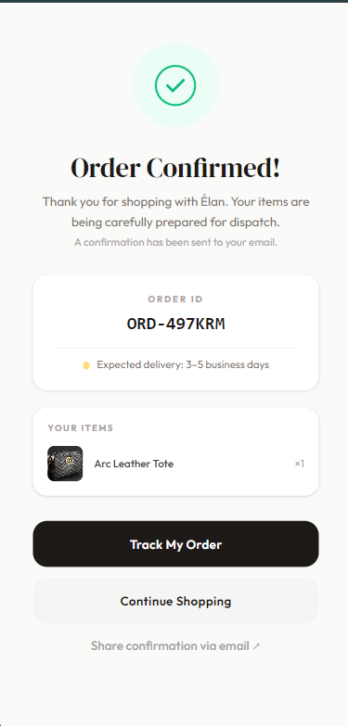
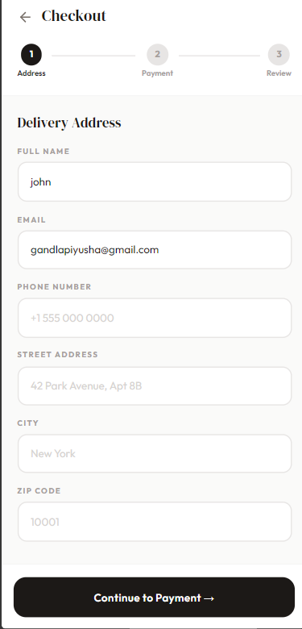
EXPERIMENT 4

Create a Scrum Project in Jira.
• Add a backlog with at least 5 items (e.g., "Create user
registration page", "Develop API for login").
• Prioritize the backlog and create a 1-week sprint.
• Move backlog items into the sprint and start the sprint.
• Finally show the Screenshot of the sprint board at the start and
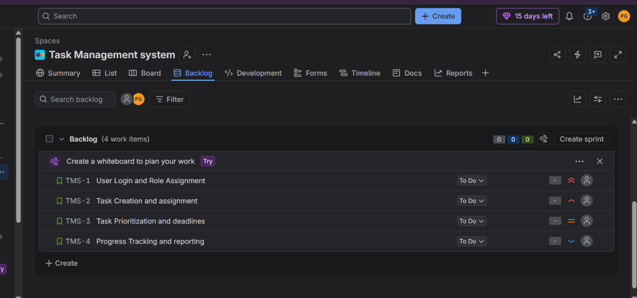
end of the sprint.

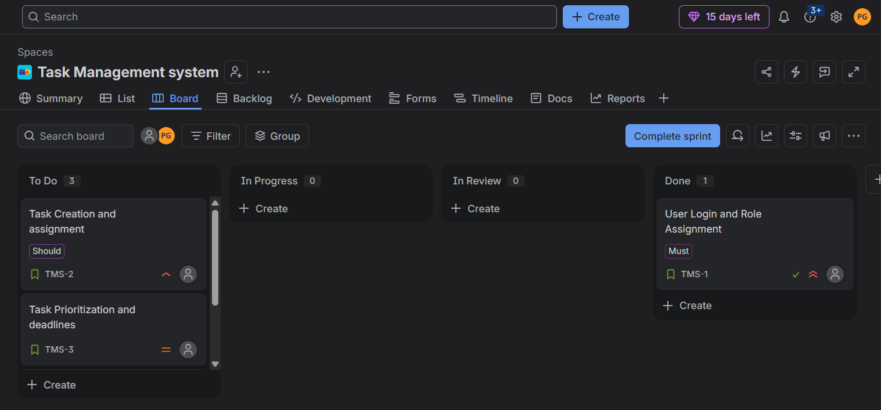

EXPERIMENT 5

Use the following requirements for a Library Management System:
• Add a feature to search books by title and author.
• Implement an online book reservation system.
• Generate monthly reports on borrowed books for
administrators.
• Enable email notifications for overdue books.
• Add support for QR code scanning for borrowing and
returning books.
• Create a user-friendly dashboard for librarians.
• Allow users to review and rate books.
• Integrate a chatbot for user assistance.
• Develop a mobile app version of the system.
• Provide multi-language support.
Categorize each requirement using MOSCOW Method (Must-Have,
Should-Have, Could-Have, or Won’t-Have) based on the following
criteria:
• Impact on the users and stakeholders.
• Feasibility considering time, budget, and resource constraints.
Finally Submit the completed Google Sheet or Excel file with all
requirements categorized and justified.

